Minesweeper (*Offline*)

**1) Note**- This program is tested on Windows 10 x64 (64-bit), so if you're on any other OS, you might encounter some compatibility issue, you can report me at [LinkedIn](http://www.linkedin.com/in/samyak-jain-5936751a8) or [Mail](mailto:samyak6540@gmail.com) me.

**2)** *Windows protected your PC*

*Microsoft Defender SmartScreen prevented an unrecognized app from starting. Running this app might put your PC at risk.*

**SUMMARY**

When launching the application for the first time, you may see this warning (if you’re on Windows and your SmartScreen is on).

**CAUSE**

This warning is just because I am not a known(recognized) publisher to *Microsoft Windows*, and doesn’t mean that the file has virus or something, at all! You can scan the folder with your antivirus.

**RESOLUTION**

Only if you have downloaded the game from my github link (<github.com/samyak1409/Minesweeper-for-PC>), you can completely trust it and simply proceed by clicking *More Info* -> *Run Anyway*.

SOURCES ->

[MSDN Blog](http://blogs.msdn.com/b/vsnetsetup/archive/2013/01/09/windows-smartscreen-prevented-an-unrecognized-app-from-running-running-this-app-might-put-your-pc-at-risk.aspx)

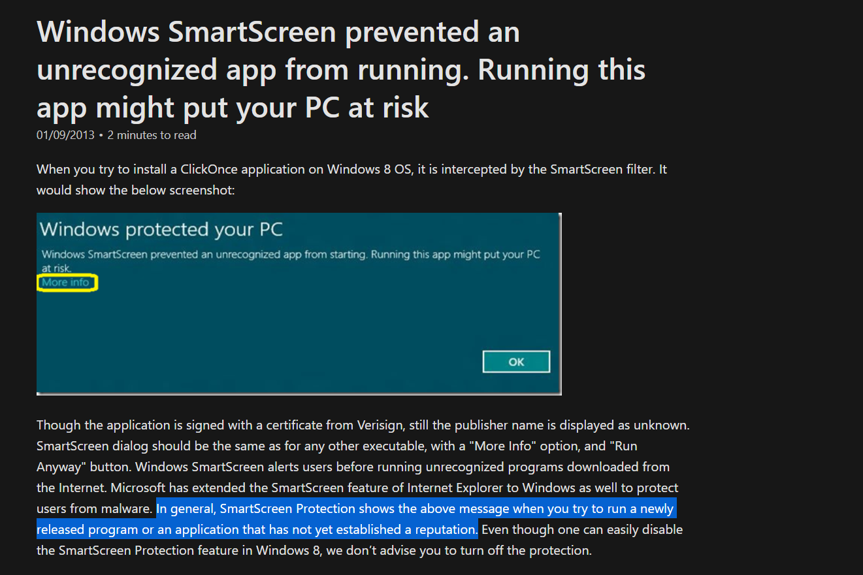

<https://youtu.be/KSDM6d9B2K8>

**3) Music Error (Windows) -** *Failed loading libmpg123.dll*

This error occur when the [DLL](https://en.wikipedia.org/wiki/Dynamic-link_library) (Dynamic-Link Library) is not found or is outdated, updating fixes the error.

Download [this](https://www.dllme.com/getfile.php?file=25787&id=a6e270ee265d6e6cebfb182f4e24c827) file and paste it in *C:\Windows\System32* and restart the game.

Sources-

<https://support.microsoft.com/en-in/help/815065/what-is-a-dll>

<https://www.dllme.com/dll/files/libmpg123_dll.html>

THANKS!